# MINI PROJECT – I

**(2019-2020)**

# Alcohol and Smoke Detection

# 

**Mid Term Report**



**Institute of Engineering & Technology**

**Team Members**

Manish Saraswat

171500181

Pranav Agarwal

171500224

## Supervised By

**Mr. Akash Kumar Chaudhary**

**Technical Trainer**

**Department of Computer Engineering & Applications**

**Name/Title of the project**

Alcohol and Smoking Sensor

**Problem Statement**

A college having a large campus and a large number of students who are involve in many types of addiction like drinking alcohol, smoking, marijuana. Due to this they are not only affecting their life but also creating a negative image of college in the society. Daily many students use to do this activity but due to unavailability of any sensor at hostels and main college gate, those students are never caught in their college life. Moreover, nowadays many accidents are taking place due to drinking of alcohol of driver.

**Reason for selecting the topic**

Due to increase of these activities a lot among student, we decide to select this topic for the sake of their life and to make college free from such activities and make happy and green environment. Moreover, to reduce the road accidents which are increasing at a rapid rate and prevent human loss.

**Objectives of the project**

*The objectives of the project are as follows*:

1. To stop drinking and smoking activities in campus.
2. To stop the activity of driving car in intoxication state.

**Literature Survey/Feasibility Study**

In this project we will describes the alcohol detection system for vehicle by using alcohol sensor, Node MCU, Android studio, Arduino ide. Here we discuss about the smart alcohol detection for vehicle protection as well for university security system. This project introduces methods such as alcohol detection and personal identification system and discuss how they can be implemented to avoid accidents. Instead of using Raspberry pi in this project they used Arduino.

**Future Scope**

This will help a lot more in society in many different ways:

1. To control illegal activities among students
2. To control road accidents which take place due to intoxication of driver.
3. Helpful for police and provides and automatic safety systems for cars and other vehicles as well.
4. Quick and accurate results

**Methodology**

We are creating a hardware consists of sensor and power supporting device to make it portable and can be use at various place and moreover we will create an android application to give the interface to the hardware and maintain its monitoring through it.

**Hardware and Software to be used**

1. *Hardware****:***

* Minimum 8GB Ram
* MQ-3 sensor
* Node MCU
* Smoke Sensor

1. *Software*:

* Arduino ide
* Android Studio

**Testing technologies to be used**

* Smartphone

**Applications**

1. Alcohol detector project can be used in the various vehicles for detecting whether the driver as consumed alcohol or not.
2. This project can also be used in various companies or organizations to detect alcohol consumptions of employees.

**What contribution would the project make and where?**

This project will be helping in controlling the intoxication at various places to protect their lives from various harmful diseases which even cause death and moreover it will decrease the road accidents which needs to control at this stage where it is increasing rapidly.

**Scope for extension into a major project**

Things that can be added to extend this project into a major one:

1. Ignition interlock device is a kind of machine that is directly connected to an ignition system of the vehicle.
2. Automatic Report to be sent to College officials, Parents if student found involve in intoxication.

Progress Details:

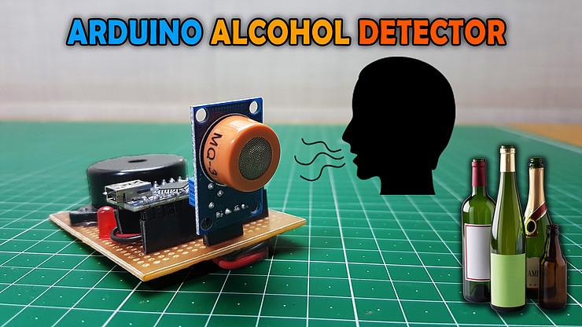

(Pictorial view of project)

Pseudo Model:

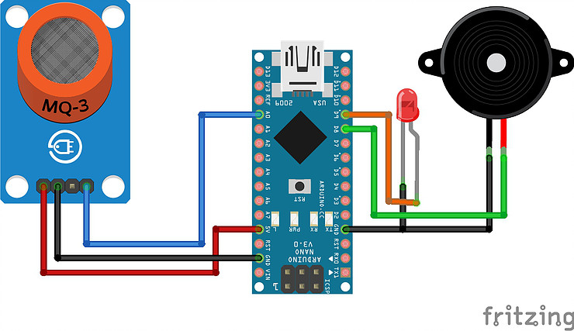

ER Diagram:

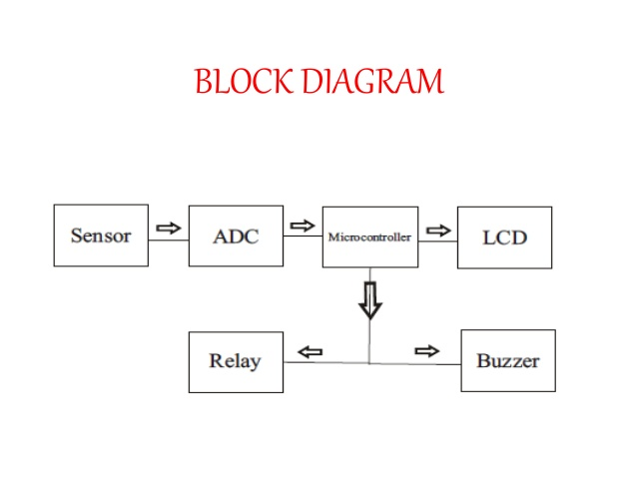

Code:

//Alcohol Detector

const int MQ3=0;

const int Buzzer=8;

const int LED=9;

int value;

void setup() {

Serial.begin(9600);

pinMode(MQ3, INPUT);

pinMode(Buzzer, OUTPUT);

pinMode(LED, OUTPUT);

digitalWrite(Buzzer,LOW);

digitalWrite(LED,LOW);

}

void loop()

{

value= analogRead(MQ3);

Serial.println(value);

if(value>440)

{

digitalWrite(Buzzer,HIGH);

digitalWrite(LED,HIGH);

}

else

{

digitalWrite(Buzzer,LOW);

digitalWrite(LED,LOW);

}

delay (500);

}

**Bibliography**

1. https://[www.javatpoint.com](http://www.javatpoint.com)
2. <https://cloud.google.com/iot/docs/>
3. <https://developer.android.com/docs>
4. <https://dart.dev/guides>
5. <https://flutter.dev/docs>